|  |
| --- |
| National University of science and technology |
| Advance Programming |
| Assignment 1 |
|  |
| **Maryam Rashid BSCS 7-A** |
| **07-Sep-19** |

**Open source software: *Zen cart***

**Type: *E-commerce***

Zen cart is an open source e-commerce software that provides developers and entrepreneurs an easy platform to communicate with people interested in purchasing products. This detailed document explains how Zen cart can be used by ordinary users, admins of the website, database developers, and programmers.

**Exploring Zen cart as a user:**

Zen cart provides several features to its users which differ from ordinary shopping stores and e-commerce websites. These are explained below:

* **Products Categorized and subcategorized:**

The following image shows a list of built-in categories of products available.

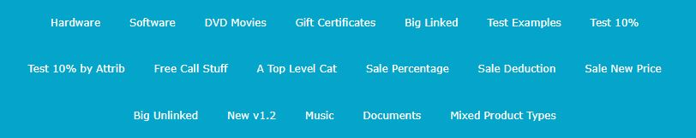

This categorization aids the user in choosing his desired product. Subcategories are also available for example DVD Movies option contains a list of genre which includes Action, Comedy, Drama, Horror etc. Featured products and best sellers category is also available.

* **Sales according to percentage, prices or quantity of products:**

This feature makes Zen cart unique. Sales according to price ($20 discount), percentage (50% off) and quantity are available which means that the greater the quantity of products purchased the greater would be the discount per single product.

* **PDF Documents:**

The products also include PDF documents. Some are available for downloading and some need to be purchased.

* **Call for price Feature:**

The prices of some products are not available. Such products are called “call for price products”. Their prices can be communicated to the user personally through phone call.

* **Filters and advance search option:**

In order to make it easier for the user to find his/her desired product, Zen cart allows users to search the product according to manufacturer’s name, price, name of product, weight of product etc.



* **Reviews:**

Not only can a user read reviews on a particular product, he/she can also give his/her own review about a product. This feature will help users trust a product before purchasing.

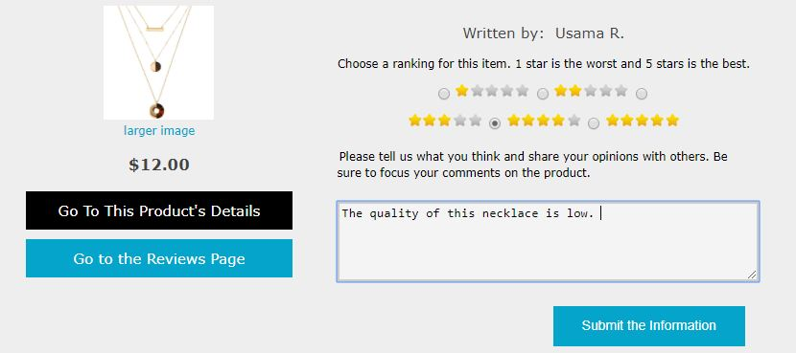

* **Newsletter subscriptions:**

User can choose whether or not to receive notifications and the monthly newsletter.

* **Multiple currency support and shipping options**
* **Manageable user account:**

The user can view products even if he doesn’t have an account however he cannot place any item into his cart unless he first logs in or signs up. The user account is easy to manage and update anytime.

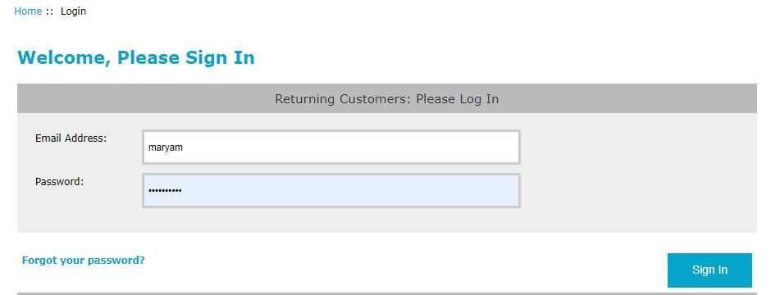

**Exploring Zen cart as an Admin:**

Zen cart is very easy to use as an admin. Zen cart allows the admin to make any kind of modifications he would like to add to his website, which may include making a new category of products or deleting unavailable products, changing prices, adding new sales, editing descriptions etc. These modifications automatically make changes into the php code or database as required so the admin does not necessarily need to understand any complex programming language or database handling techniques. Following features are made available to the admin:

* Zen cart allows customers to shop 24 hours a day, 7 days a week.
* Easily keeps products/catalog updated. No HTML coding is required to add, delete, or modify products.
* Works on the popular combination of PHP and MySQL technologies.
* Zen cart is highly secure. No one but administrative personnel can access customer/catalog data. The customer password is encrypted before it is saved into the database.
* Easy to install.
* User reviews can be approved before the admin chooses to upload them.

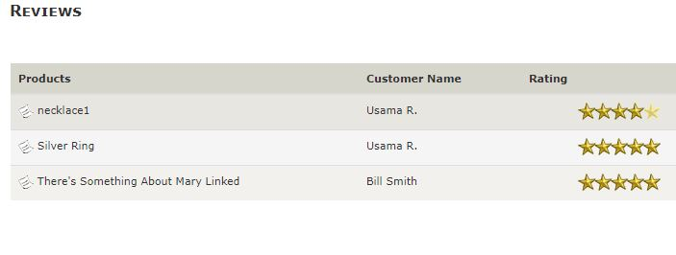

* Admin can update payment and currency details.
* Admin can easily create new categories, subcategories; include images of products, their prices and detailed description. Admin can also specify genre of movies or music and give manufacturers details.

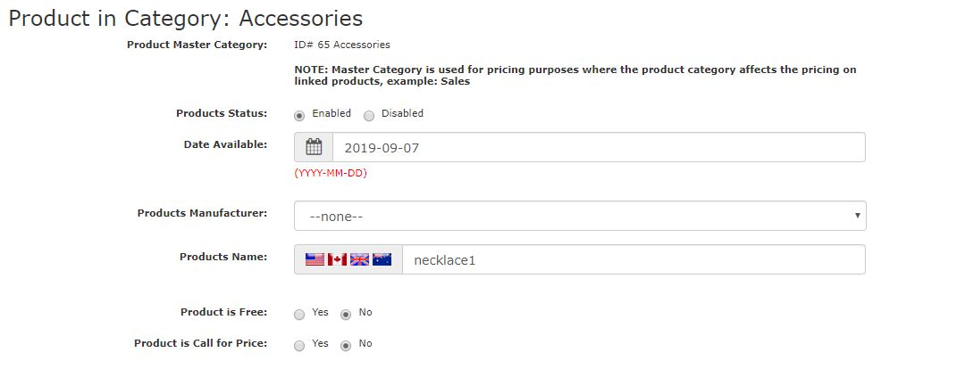

* Image sizes can be modified.
* Multiple admins can use one website. Their information is saved into the database once an admin signs up.
* Newsletter upload options are also available to the admin.
* Certain minimum/maximum values can be updated for example minimum number of products available as Best Sellers can be set to 1.

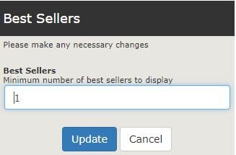

**Exploring Zen cart as a Coder and Database Developer:[1]**

Like all professional websites Zen cart has a highly complex database structure consisting of more than 50 tables most of which are linked with one another through foreign keys and through other smaller tables. The database can be divided into the following groups:

1. **Product information tables**

Some of the most important tables in this group are Product types, Product descriptions, Manufacturers, Categories and Reviews. All are interlinked with one another through primary and foreign keys. For example each product has a unique ID that is a part of every table.

1. **Customer related tables**

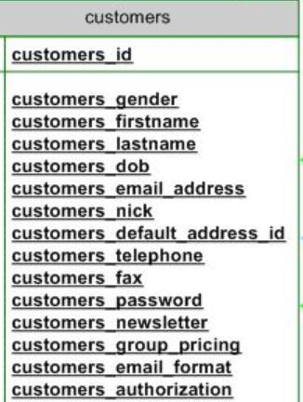This includes tables about customer contact information and their shopping carts. Attributes include customer unique id, email address, date the account was created, IDs of the product they placed into their carts, order number, customer name, gender etc.

The products and customers are linked with one another through a table called product_notification. This table uses a composite primary key. Several tables can be found in these databases that make use of composite primary keys to create meaningful connections.

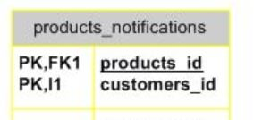

1. **Sales and pricing tables**

This group includes featured items, sale-maker sales, and specials tables.

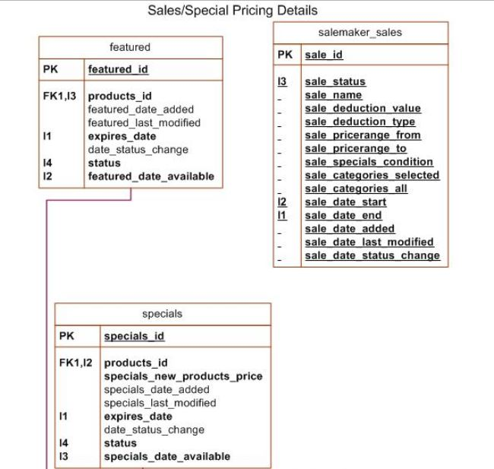

1. **Content management tables**

This group consists of a single table named EZ pages which contains data about internal and external links that can be accessed through the website.

1. **Order history tables**

The Order table holds data about the orders placed by customers. Therefore this table has an important link with the customers table and the products table. Primary and foreign keys help to create this connection.

1. **Admin Information tables**

Just as the customer information is stored into the database, the Admin details too are kept here. However private data such as passwords are encrypted to enhance security.

1. **Coupons tables**

Seven tables are part of this group namely; coupons, coupons_restrict, coupon_email_track, coupon_description, coupon_customer, coupon_queue and coupon_redeem_track.

1. **Tax/Zone configuration tables**

Data regarding taxes and countries the customers belong to are saved here.

1. **System Configuration tables**

Language, currencies, layouts and template information is stored here in the form of tables.

Zen cart open source software contains a number of files and directories most of which are HTML or PHP or CSS files. JPG files are also present. Some of the most significant directories are:

* The “includes” folder: This folder contains a number of other folders such as templates and modules.
* The “image” folder: contains images, logos and other JPG files.
* The “docs” folder: contains HTML files related to basic installation and upgrading instructions.

**Customizing Zen cart:**

Zen cart allows admins to make modifications in the website and enhance its look and feel by installing some additional modules. Several types of modules are present at Zen cart’s original website. These modules include template designs, CSS styling, Payment methods, Shipping methods, Zen lightbox, Newsletter subscriptions etc.

Following are some of the changes I made in the website by installing plug-ins:

**Original template:**

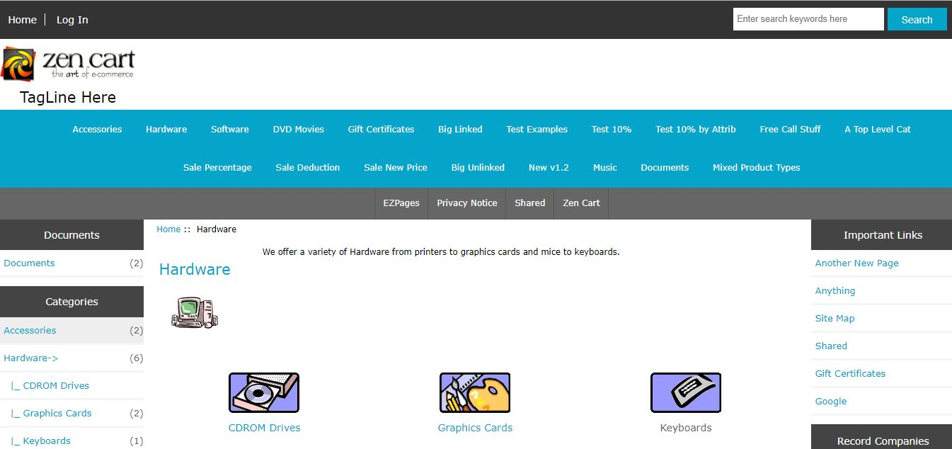

**New templates:**

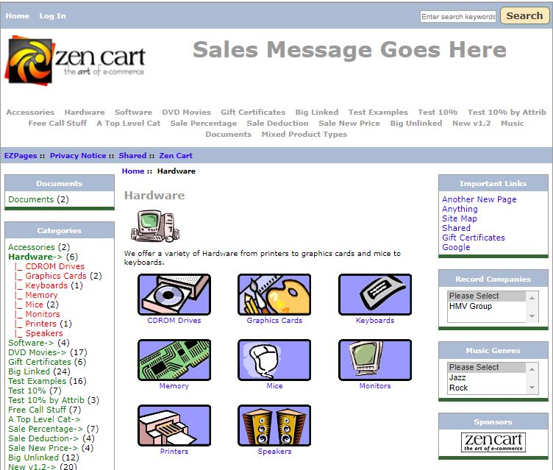

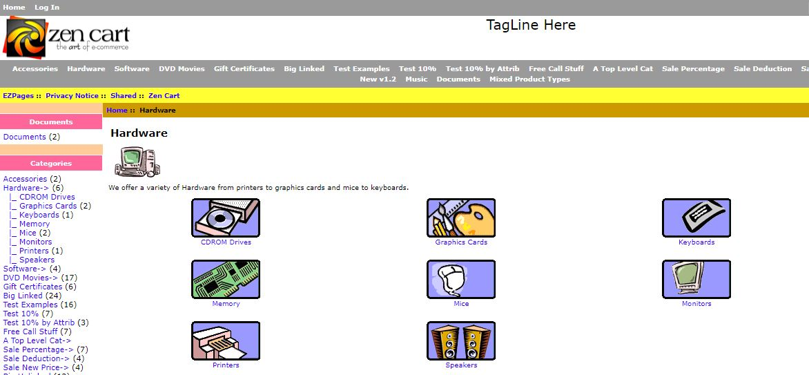

**Cash on delivery module:**

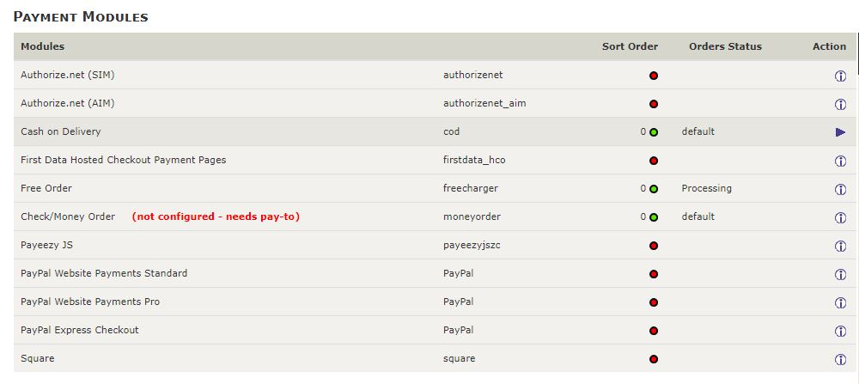

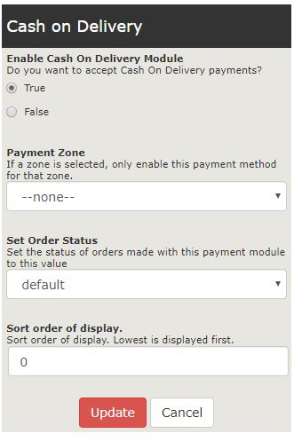

1. References:

   <https://upload.wikimedia.org/wikipedia/commons/f/f6/ZenCart_DB_Schema.jpg>